**IBM CAREER EDUCATION**

**MAIN PROJECT**  
**DOMAIN NAME: JAVA**

**TELEPHONE BILLING SYSTEM**

**Submitted By :-**

**Jeet Shah (18162101030)**

**Yash Pendal (18162101026)**

**Dev Punjabi (18082271005)**

**Submitted To:-**

**A. Saai Sanjeev Achaarya**

**IBM Technical Software Trainer**

**TELEPHONE BILLING SYSTEM**

**FLOWCHART**

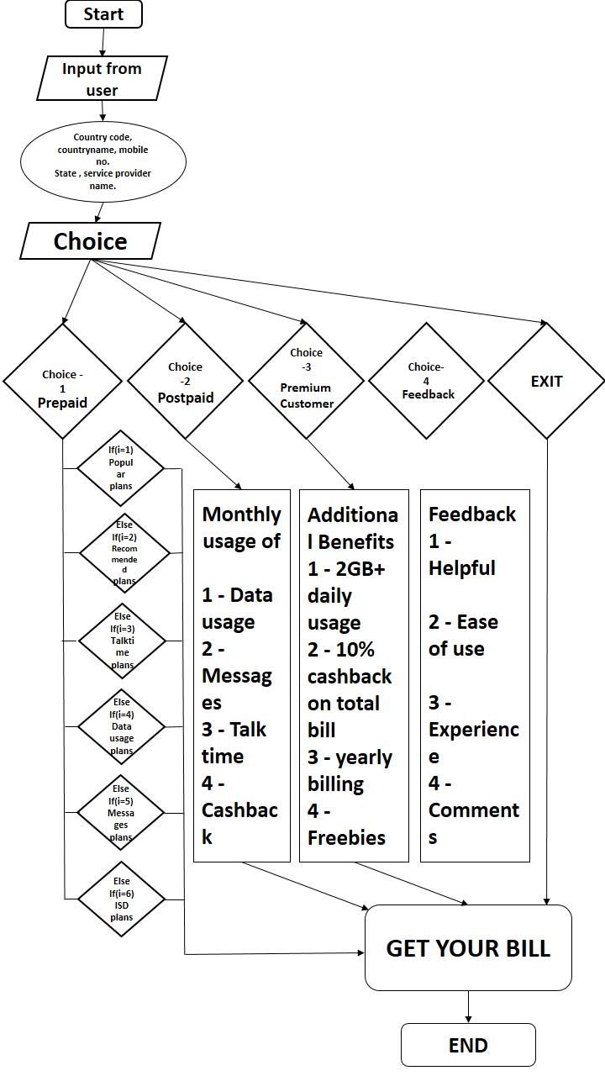

**TELEPHONE BILLING SYSTEM**

**SOFTWARE SPECIFICATIONS**

* OPERATING SYSTEM : LINUX/WINDOWS
* ENVIRONMENT : IBM RAD

**HARDWARE SPECIFICATIONS**

* PROCESSOR : CORE i3 7th Gen
* RAM : 4 GB
* MONITOR : 15 ” BLACK
* HARD DRIVE : 40 GB
* FLOPPY DRIVE : 1.44 MB

**TELEPHONE BILLING SYSTEM**

**DESCRIPTION**

**INTRODUCTION :**

Telephone Billing System in Java is a simple software application developed to improve the efficiency in telephone billing procedures in telecommunication service providers and other suitable organizations. With this system, user billing details can be easily calculated and managed. Overall, a computerized telephone billing system increases the speed of the billing procedure, bill calculation and final report generation.

**DESCRIPTION:**

This Telephone Billing System is a totally computerized system that aims at quick, effective and uncomplicated telephone billing procedure. With this software, the workload for both customers and telecommunication service providers is reduced and the flow of the work is enhanced. More work can be done in lesser time with the new telephone billing system.

Information retrieval, recording and management has become easy and straightforward. As security is given prime importance in this Telephone Billing System, there’s less chance of data mishandling. Also, the software is very easy to use and does not require much skills; a person with basic knowledge of computer can effectively understand the billing procedure incorporated in this software.

**PROS:**

* It can easily be used in combination with other telephone billing subsystems.
* It has consistent interface with high economic options.
* User-friendly; error messages are displayed in a square box on the screen.
* Addition, deletion and editing of existing/new records can be done when required.
* Automatic and fast bill generation.
* Optimized way of paying the telephone bills.
* Day to day usage of this system and thus being user-friendly and also convenient.
* Easy track of previous bills.
* In terms of accessibility it can be accessed anytime anywhere.

**CONS:**

* Everything is dependent on one system.
* Security concerns regarding the data being involved in it.
* Regular tracking is necessary.

**Existing System:**

* All the works in the workspace are done manually.
* It is slow and tedious.
* Adding, editing, deleting or searching for records in the files/registers is slow.
* Maintenance and handling of works of large volume is cumbersome in itself.
* The existing system is very error-prone.
* Updating is difficult and may require new registers/files in most cases.

**TELEPHONE BILLING SYSTEM**

**PICTURES**

**Telephone /Mobiles**

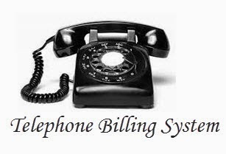

**Pay anytime & anywhere**

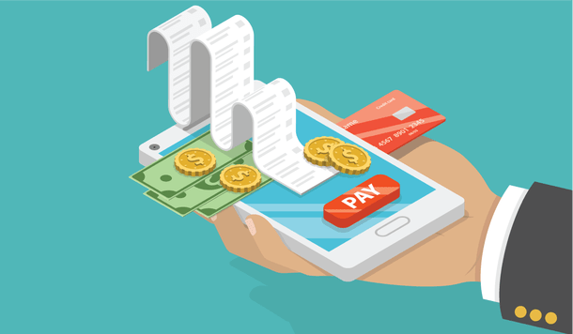

**PICTURES**

**File System to Computerized System**

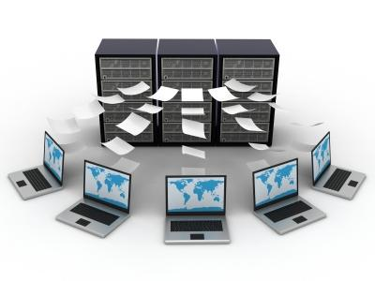

**Stay updated every time**

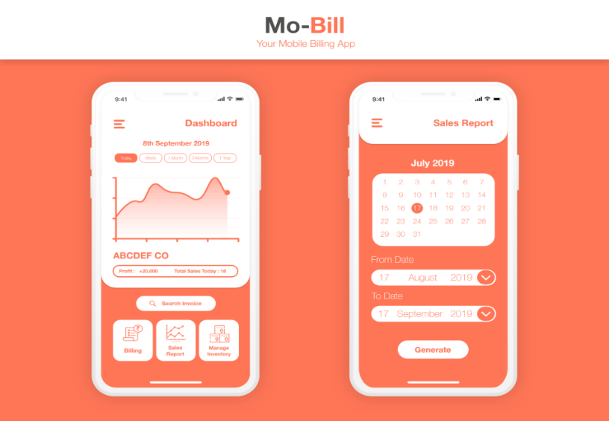

**CODE:**

import java.util.*;

class base

{

int select,select1,select2;

int amount=0,ttl_amount=0,voucher=0,voucher_m=0,cashback;

int pp,rp,tt,du,mb,isd,is;

int q1,q2,q3;

String q4;

String c_name;

short c_code;

long u_p_num;

String u_state,u_pd_name,sim_type;

void putdata()

{

Scanner sc = new Scanner(System.in);

System.out.println("------------------------------------------");

System.out.println(" ");

System.out.println(" Telephone Billing System ");

System.out.println(" ");

System.out.println("------------------------------------------");

System.out.println("\n Enter the Country Code :- ");

System.out.print("+");

c_code = sc.nextShort();

if(c_code==91)

{

System.out.println("\nYour country is INDIA.");

c_name="INDIA";

}

else

{

System.out.println("\n Enter the Country Name :- ");

c_name = sc.next();

}

System.out.println("\n Enter the Customer Mobile Number :- ");

System.out.print("+"+c_code );

u_p_num = sc.nextLong();

System.out.println("\n Enter the State Name :- ");

u_state = sc.next();

System.out.print("Your state "+u_state);

System.out.println(" has following service providers. Choose any one of these: ");

System.out.println("1.Airtel");

System.out.println("2.Bsnl");

System.out.println("3.Jio");

System.out.println("4.Vodafone");

System.out.println("\n Enter the Service Provider Name :- ");

u_pd_name = sc.next();

System.out.println("\n Enter the Choice : ");

System.out.println("Press 1 for Post Paid.");

System.out.println("Press 2 for Pre Paid.");

System.out.println("Press 3 to become our Premium Customer.");

System.out.println("Press 4 for the Feedback.");

System.out.println("Press 5 to exit.");

select = sc.nextInt();

switch(select)

{

case 1:

sim_type = "Post Paid";

System.out.println("\nThe code for your Post-Paid plan was PP01.");

System.out.println("The plan included of 75GB with rollover + Free UNLIMITED calling + No roaming charges + upto 100 SMS per day.");

System.out.println("You have used 61.76GB of which the remaining 13.24GB will get rollover to the next month.");

System.out.println("You also had talktime of 3000 minutes and an average of 20 messages per day.");

System.out.println("The monthly rent for the same is stated at Rs.499/- for the month of September.");

System.out.println("You are also provided with additional voucher worth Rs.100/- for FREE every month.");

System.out.println("The due date of the bill is on 20/10/2019.");

System.out.println("*If not paid before the due date additional charges may apply as per the terms and conditions of it.");

System.out.println("As you have been our Post-Paid customer.So this DIWALI festive season "+ u_pd_name +" would like to given you cashback of 5% on total bil.");

amount = amount + 499;

voucher = voucher + 100;

voucher_m =0;

ttl_amount = ttl_amount +amount -voucher + voucher_m;

cashback=ttl_amount/5;

System.out.println("You have saved Rs."+cashback+"on this transaction.");

ttl_amount=ttl_amount-cashback;

break;

case 2 :

sim_type = "Pre Paid";

System.out.println("\n Enter the Choice : ");

System.out.println("Press 1 for Popular plans.");

System.out.println("Press 2 for Recommended plans.");

System.out.println("Press 3 for Talk-Time based plans.");

System.out.println("Press 4 for Data-Usage based plans.");

System.out.println("Press 5 for Message based plans.");

System.out.println("Press 6 for ISD plans.");

select1 = sc.nextInt();

switch(select1)

{

case 1:

System.out.println("You have opted for Popular Plans.");

System.out.println("Plan-1:");

System.out.println("a) Daily Data-Usage of 2GB(56).Beyond it the speed gets reduced @64kbps.");

System.out.println("b) Free talktime to other users of "+u_pd_name+".Non-"+u_pd_name+" FUP of 1,000 minutes.");

System.out.println("c) Upto 100 daily messages.");

System.out.println("d) Validity: 28days.");

System.out.println(" Price:222/-");

System.out.println("Plan-2:");

System.out.println("a) Daily Data-Usage of 2GB(168).Beyond it the speed gets reduced @74kbps.");

System.out.println("b) Free talktime to other users of "+u_pd_name+".Non-"+u_pd_name+" FUP of 3,000 minutes.");

System.out.println("c) Upto 100 daily messages.");

System.out.println("d) Validity: 84days.");

System.out.println(" Price:555/-");

System.out.println("Enter the choice of plan you want:");

pp= sc.nextInt();

if(pp == 1)

{

System.out.println("You have opted for Plan-1 from Popular Plans.");

amount=amount + 222;

voucher=0;

voucher_m=0;

ttl_amount=ttl_amount + amount + voucher + voucher_m;

}

else if(pp == 2)

{

System.out.println("You have opted for Plan-2 from Popular Plans.");

amount=amount +555;

voucher=0;

voucher_m=0;

ttl_amount=ttl_amount + amount + voucher + voucher_m;

}

else

{

System.out.println("Invalid choice.");

}

break;

case 2:

System.out.println("You have opted for Recommended plans.");

System.out.println("Plan-1:");

System.out.println("a) Daily Data-Usage of 2GB(56).Beyond it unlimited Data-Usage @64kbps.");

System.out.println("b) Free talktime to other users of "+u_pd_name+".");

System.out.println("c)TRAI has compelled "+u_pd_name+" to recover IUC of 6 paise/minute for all mobile voice calls to other operators.");

System.out.println("d) Rs.20/- (Top Up Voucher -IUC) 249 IUC Minutes");

System.out.println("e) Upto 100 daily messages.");

System.out.println("f) Validity: 28days.");

System.out.println(" Price:198/-");

System.out.println("Plan-2:");

System.out.println("a) Daily Data-Usage of 2GB(56).Beyond it unlimited Data-Usage @64kbps.");

System.out.println("b) Free talktime to other users of "+u_pd_name);

System.out.println("c)TRAI has compelled "+u_pd_name+" to recover IUC of 6 paise/minute for all mobile voice calls to other operators.");

System.out.println("d) Rs.50/- (Top Up Voucher -IUC) 656 IUC Minutes");

System.out.println("e) Upto 100 daily messages.");

System.out.println("f) Validity: 28days.");

System.out.println(" Price:198/-");

System.out.println("Enter the choice of plan you want:");

rp= sc.nextInt();

if(rp == 1)

{

System.out.println("You have opted for Plan-1 from Recommended Plans.");

amount=amount +198;

voucher=voucher + 20;

voucher_m=0;

ttl_amount=ttl_amount + amount + voucher + voucher_m;

}

else if(rp == 2)

{

System.out.println("You have opted for Plan-2 from Recommended Plans.");

amount=amount +198;

voucher=voucher + 50;

voucher_m=0;

ttl_amount=ttl_amount + amount + voucher + voucher_m;

}

else

{

System.out.println("Invalid choice.");

}

break;

case 3:

System.out.println("You have opted for Talk-Time based Plans.");

System.out.println("Plan-1:");

System.out.println("a) Daily Data-Usage of 1.5GB(42).Beyond it unlimited Data-Usage @64kbps.");

System.out.println("b) Free talktime to other users of "+u_pd_name+".");

System.out.print("c)TRAI has compelled "+u_pd_name+"to recover IUC of 6 paise/minute for all mobile voice calls to other operators.");

System.out.println("d) Rs.100/- (Top Up Voucher -IUC) 1362 IUC Minutes");

System.out.println("e) Upto 100 daily messages.");

System.out.println("f) Validity: 28days.");

System.out.println(" Price:149/-");

System.out.println("Plan-2:");

System.out.println("a) Daily Data-Usage of 1.5GB(42).Beyond it unlimited Data-Usage @64kbps.");

System.out.println("b) Free talktime to other users of "+u_pd_name+".");

System.out.print("c)TRAI has compelled " +u_pd_name+"to recover IUC of 6 paise/minute for all mobile voice calls to other operators.");

System.out.println("d) Rs.500/- (Top Up Voucher -IUC) 7012 IUC Minutes");

System.out.println("e) Upto 100 daily messages.");

System.out.println("f) Validity: 28days.");

System.out.println(" Price:149/-");

System.out.println("Plan-3:");

System.out.println("a) Daily Data-Usage of 1.5GB(105).Beyond it unlimited Data-Usage @64kbps.");

System.out.println("b) Free talktime to other users of "+u_pd_name+".");

System.out.print("c)TRAI has compelled " +u_pd_name+"to recover IUC of 6 paise/minute for all mobile voice calls to other operators.");

System.out.println("d) Rs.100/- (Top Up Voucher -IUC) 7012 IUC Minutes");

System.out.println("e) Upto 100 daily messages.");

System.out.println("f) Validity: 70days.");

System.out.println(" Price:349/-");

System.out.println("Enter the choice of plan you want:");

tt= sc.nextInt();

if(tt == 1)

{

System.out.println("You have opted for Plan-1 from Talk-Time based Plans.");

amount=amount +149;

voucher=voucher + 100;

voucher_m=0;

ttl_amount=ttl_amount + amount + voucher + voucher_m;

}

else if(tt == 2)

{

System.out.println("You have opted for Plan-2 from Talk-Time based Plans.");

amount=amount +149;

voucher=voucher + 500;

voucher_m=0;

ttl_amount=ttl_amount + amount + voucher + voucher_m;

}

else if(tt == 3)

{

System.out.println("You have opted for Plan-3 from Talk-Time based Plans.");

amount=amount +349;

voucher=voucher + 100;

voucher_m=0;

ttl_amount=ttl_amount + amount + voucher + voucher_m;

}

else

{

System.out.println("Invalid choice.");

}

break;

case 4:

System.out.println("You have opted for Data-Usage based plans.");

System.out.println("Plan-1:");

System.out.println("a) Daily Data-Usage of 3GB(84).Beyond it unlimited Data-Usage @64kbps.");

System.out.println("b) Free talktime to other users of "+u_pd_name+".");

System.out.println("c)TRAI has compelled "+u_pd_name+" to recover IUC of 6 paise/minute for all mobile voice calls to other operators.");

System.out.println("d) Rs.50/- (Top Up Voucher -IUC) 656 IUC Minutes");

System.out.println("e) Upto 100 daily messages.");

System.out.println("f) Validity: 28days.");

System.out.println(" Price:299/-");

System.out.println("Plan-2:");

System.out.println("a) Daily Data-Usage of 4GB(112).Beyond it unlimited Data-Usage @64kbps.");

System.out.println("b) Free talktime to other users of "+u_pd_name);

System.out.println("c)TRAI has compelled "+u_pd_name+" to recover IUC of 6 paise/minute for all mobile voice calls to other operators.");

System.out.println("d) Rs.50/- (Top Up Voucher -IUC) 656 IUC Minutes");

System.out.println("e) Upto 100 daily messages.");

System.out.println("f) Validity: 28days.");

System.out.println(" Price:509/-");

System.out.println("Enter the choice of plan you want:");

du= sc.nextInt();

if(du == 1)

{

System.out.println("You have opted for Plan-1 from Data-Usage based Plans.");

amount=amount +299;

voucher=voucher + 50;

voucher_m=0;

ttl_amount=ttl_amount + amount + voucher + voucher_m;

}

else if(du == 2)

{

System.out.println("You have opted for Plan-2 from Data-Usage based Plans.");

amount=amount +509;

voucher=voucher + 50;

voucher_m=0;

ttl_amount=ttl_amount + amount + voucher + voucher_m;

}

else

{

System.out.println("Invalid choice.");

}

break;

case 5:

System.out.println("You have opted for Message based plans.");

System.out.println("Plan-1:");

System.out.println("a) Daily Data-Usage of 1.5GB(42).Beyond it unlimited Data-Usage @64kbps.");

System.out.println("b) Free talktime to other users of "+u_pd_name+".");

System.out.println("c)TRAI has compelled "+u_pd_name+" to recover IUC of 6 paise/minute for all mobile voice calls to other operators.");

System.out.println("d) Rs.50/- (Top Up Voucher -IUC) 656 IUC Minutes");

System.out.println("e) Upto 100 daily messages."+"Additional ");

System.out.println("d) Rs.20/- (Top Up Voucher -Messages) 222 messages");

System.out.println("f) Validity: 28days.");

System.out.println(" Price:149/-");

System.out.println("Plan-2:");

System.out.println("a) Daily Data-Usage of 1.5GB(105).Beyond it unlimited Data-Usage @64kbps.");

System.out.println("b) Free talktime to other users of "+u_pd_name);

System.out.println("c)TRAI has compelled "+u_pd_name+" to recover IUC of 6 paise/minute for all mobile voice calls to other operators.");

System.out.println("d) Rs.50/- (Top Up Voucher -IUC) 656 IUC Minutes");

System.out.println("e) Upto 100 daily messages.");

System.out.println("d) Rs.50/- (Top Up Voucher -Messages) 550 Messages");

System.out.println("f) Validity: 70days.");

System.out.println(" Price:349/-");

System.out.println("Enter the choice of plan you want:");

mb= sc.nextInt();

if(mb == 1)

{

System.out.println("You have opted for Plan-1 from Message based Plans.");

amount=amount +149;

voucher=voucher + 50;

voucher_m=voucher_m +20;

ttl_amount=ttl_amount + amount + voucher + voucher_m;

}

else if(mb == 2)

{

System.out.println("You have opted for Plan-2 from Message based Plans.");

amount=amount +349;

voucher=voucher + 50;

voucher_m=voucher_m +50;

ttl_amount=ttl_amount + amount + voucher + voucher_m;

}

else

{

System.out.println("Invalid choice.");

}

break;

case 6:

System.out.println("You have opted for ISD Plans.");

System.out.println("Press 1 for Plan.");

System.out.println("Press 2 for other options.");

select2 = sc.nextInt();

switch(select2)

{

case 1:

System.out.println("-] It is a global ISD plan.");

System.out.println("a) ISD talk-time of Rs 501/- + additional ISD talk-time of Rs 54/-.");

System.out.println("b) Equivalent ISD talk-time is Rs 555/-.");

System.out.println("c) Validity: 28days.");

System.out.println(" Price:501/-");

amount= amount + 501;

voucher=0;

voucher_m=0;

ttl_amount=ttl_amount + amount + voucher + voucher_m;

break;

case 2:

System.out.println("For individual country benefits:-");

System.out.println("1) Australia");

System.out.println("2) United Kingdom");

System.out.println("3) United States of America");

System.out.println("We provide our services in above mentioned countries only.");

System.out.println("Choose the country:");

isd= sc.nextInt();

if(isd == 1)

{

System.out.println("You have selected Australia for ISD calling.");

System.out.println("Price(in Rs) is 4/min.");

amount=amount + 501;

voucher=0;

voucher_m=0;

ttl_amount=ttl_amount + amount + voucher + voucher_m;

is=amount/4;

System.out.println("Hence you would get "+ is +"minutes");

}

else if(isd == 2)

{

System.out.println("You have selected United Kingdom for ISD calling.");

System.out.println("Price(in Rs) is 2/min.");

amount=amount + 501;

voucher=0;

voucher_m=0;

ttl_amount=ttl_amount + amount + voucher + voucher_m;

is=amount/2;

System.out.println("Hence you would get "+ is +"minutes");

}

else if(isd == 3)

{

System.out.println("You have selected United States of America for ISD calling.");

System.out.println("Price(in Rs) is 1/min.");

amount=amount + 501;

voucher=0;

voucher_m=0;

ttl_amount=ttl_amount + amount + voucher + voucher_m;

is=amount/1;

System.out.println("Hence you would get "+ is +"minutes");

}

else

{

System.out.println("Invalid choice.");

}

break;

default:

System.out.println("Inappropriate choice.");

}

break;

default:

System.out.println("Wrong input");

}

break;

case 3 :

sim_type = "Post-Paid (Exclusively)";

System.out.println("You have been one of the most faithful customer for our company.");

System.out.println("As a result of this you are a premium customer of "+ u_pd_name +" network.\n Serving you is our no.1 priority.");

System.out.println("We have brought a premium plan for the premium ones.\n It is a plan like never heard before.");

System.out.println("a) Daily Data-Usage of 2.08GB(750).Beyond it unlimited Data-Usage @64kbps.");

System.out.println("b) Free talktime to other users of "+u_pd_name+".");

System.out.println("c)TRAI has compelled "+u_pd_name+" to recover IUC of 6 paise/minute for all mobile voice calls to other operators.");

System.out.println("d) Rs.1000/- (Top Up Voucher -IUC) 14321 IUC Minutes");

System.out.println("e) Upto 100 daily messages.");

System.out.println("f) Validity: 360days.");

System.out.println(" Price:9999/-");

System.out.println("As you have been our premium customer so we would like to given you cashback of 5% on total bil.\n Also additional 5% on the total bill as for DIWALI Festive Season.");

System.out.println("Hence a total of 10% would be given as cashback on this transaction.");

amount= amount + 9999;

voucher=1000;

voucher_m=0;

ttl_amount=ttl_amount + amount + voucher + voucher_m;

cashback=ttl_amount/10;

System.out.println("You have saved Rs."+cashback+"on this transaction.");

ttl_amount=ttl_amount-cashback;

break;

case 4 :

System.out.println("Welcome to the FEEDBACK Section");

System.out.println("Following are few questions rate them accordingly on a scale of 1-5.\n1.Very Bad\t\t2.Bad\t\t3.Satisfied\t\t4.Good\t\t5.Excellent");

System.out.println("1.Helpful\nis our system helpful to you?");

q1=sc.nextInt();

if(q1==1)

{

System.out.println("Very Bad-We will try to improve it.");

}

else if(q1==2)

{

System.out.println("Bad-We will try to make it better.");

}

else if(q1==3)

{

System.out.println("Satisfied-There is always room for improvement.");

}

else if(q1==4)

{

System.out.println("Good-We would enchance it.");

}

else if(q1==5)

{

System.out.println("Excellent-We were expecting this.");

}

else

{

System.out.println("Inappropriate choice for feedback.");

}

System.out.println("2.Ease of use\nHow easy is it to use?");

q2=sc.nextInt();

if(q2==1)

{

System.out.println("Very Bad-We will try to improve it.");

}

else if(q2==2)

{

System.out.println("Bad-We will try to make it better.");

}

else if(q2==3)

{

System.out.println("Satisfied-There is always room for improvement.");

}

else if(q2==4)

{

System.out.println("Good-We would enchance it.");

}

else if(q2==5)

{

System.out.println("Excellent-We were expecting this.");

}

else

{

System.out.println("Inappropriate choice for feedback.");

}

System.out.println("3.Experience\nHow was your experience with us?");

q3=sc.nextInt();

if(q3==1)

{

System.out.println("Very Bad-We will try to improve it.");

}

else if(q3==2)

{

System.out.println("Bad-We will try to make it better.");

}

else if(q3==3)

{

System.out.println("Satisfied-There is always room for improvement.");

}

else if(q3==4)

{

System.out.println("Good-We would enchance it.");

}

else if(q3==5)

{

System.out.println("Excellent-We were expecting this.");

}

else

{

System.out.println("Inappropriate choice for feedback.");

}

System.out.println("Write a feedback\n Type your comments here:");

q4=sc.next();

System.out.println("Thanks for giving your precious time in giving us feedback.");

break;

case 5 :

System.out.println("\n Exit ");

break;

default:

System.out.println("Wrong input");

}

}

void showdata()

{

System.out.println("\n _ _ _ _ _ _ _ _ _ _ _ _ _ _ _ _ _ _ _ _ _ _ _ _ _ _ _ _ _ _ _* TELEPHONE BILL *_ _ _ _ _ _ _ _ _ _ _ _ _ _ _ _ _ _ _ _ _ _ _ _ _ _ _ _ _ _ _ _");

System.out.println("\n |Country Name :- "+ c_name +"\t\t\t\t\t\t\t\t\t\t\t\t\t\t\t|");

System.out.println("\n | |");

System.out.println("\n |Country Code :- +"+ c_code +"\t\t\t\t\t\t\t\t\t\t\t\t\t\t\t|");

System.out.println("\n | |");

System.out.println("\n |Customer Mobile Number : "+ c_code +" "+ u_p_num +"\t\t\t\t\t\t\t\t\t\t\t\t\t\t|");

System.out.println("\n | |");

System.out.println("\n |State Name :- "+ u_state +"\t\t\t\t\t\t\t\t\t\t\t\t\t\t|");

System.out.println("\n | |");

System.out.println("\n |Service Provider Name :- "+ u_pd_name +"\t\t\t\t\t\t\t\t\t\t\t\t\t\t\t|");

System.out.println("\n | |");

System.out.println("\n |Customer Service Plan Type :- " + sim_type +"\t\t\t\t\t\t\t\t\t\t\t\t\t\t|");

System.out.println("\n | |");

System.out.println("\n |Voucher-IUC(in Rs.) :- " + voucher +"/- \t\t\t\t\t" +"Voucher-Messages(in Rs.) :- "+ voucher_m +"/- \t\t\t\t\t|");

System.out.println("\n | |");

System.out.println("\n |Amount(in Rs.) :- "+ amount +"/- \t\t\t\t\t" +"Cashback(in Rs.) :- "+ cashback +"/- \t\t\t\t\t\t\t|");

System.out.println("\n | |");

System.out.println("\n |Total Amount(in Rs.) :- " + ttl_amount +"/-"+"\t\t\t\t\t\t\t\t\t\t\t\t\t\t\t|");

System.out.println("\n |_ _ _ _ _ _ _ _ _ _ _ _ _ _ _ _ _ _ _ _ _ _ _ _ _ _ _ _ _ _ _ _ _ _ _ _ _ _ _ _ _ _ _ _ _ _ _ _ _ _ _ _ _ _ _ _ _ _ _ _ _ _ _ _ _ _ _ _ _ _ _ |");

}

}

class project

{

public static void main(String[] args)

{

base b = new base();

b.putdata();

b.showdata();

}

}

**OUTPUT:**

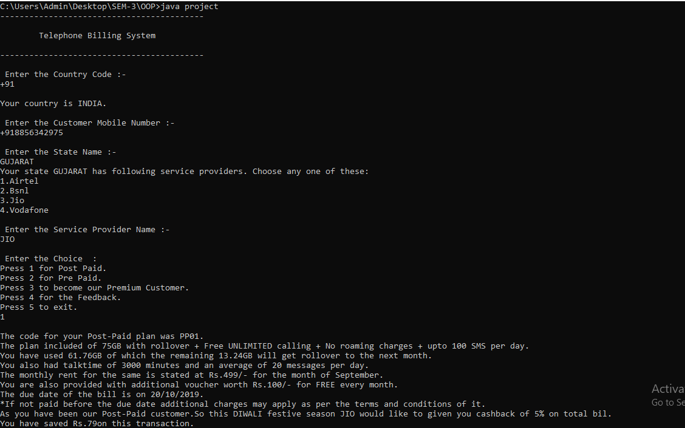

**Figure:1 A - Getting input from user**

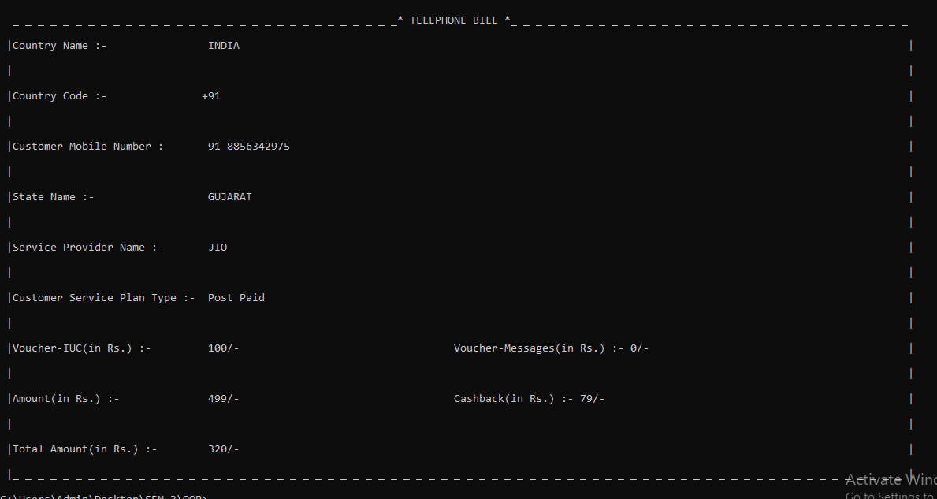

**Figure:1 B – Selecting as Post-paid**

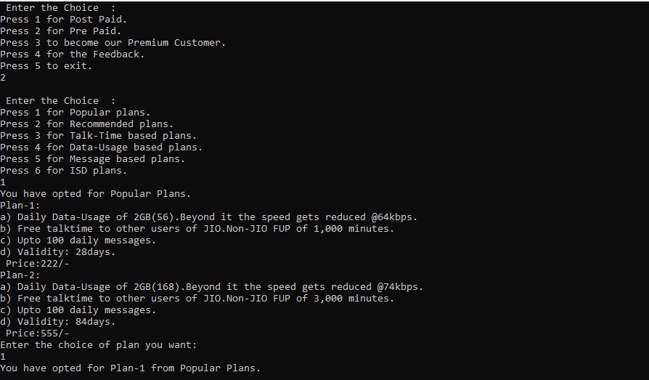

**Figure:2 A – For Pre-paid**

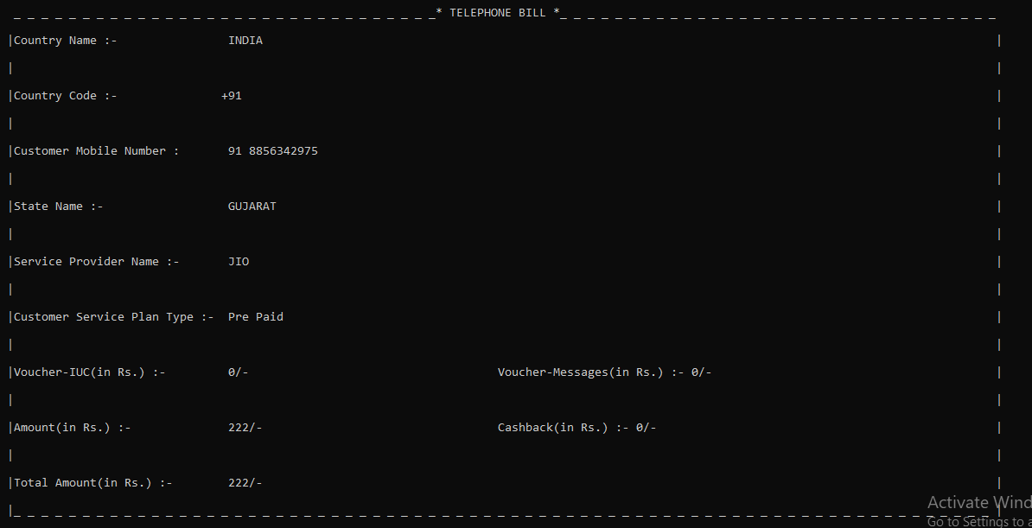

**Figure:2 B – For Pre-paid(Popular Plan)**

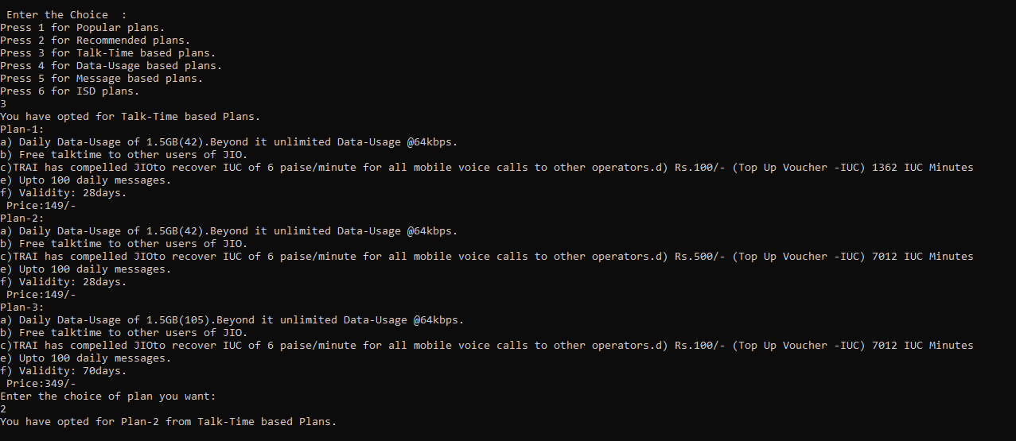

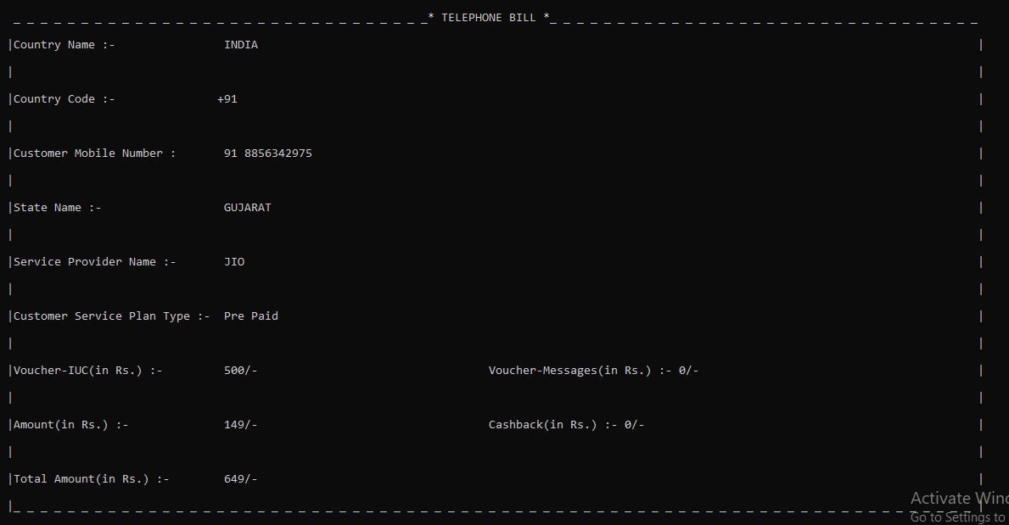

**Figure:2 C – For Pre-paid(Talktime Plan)**

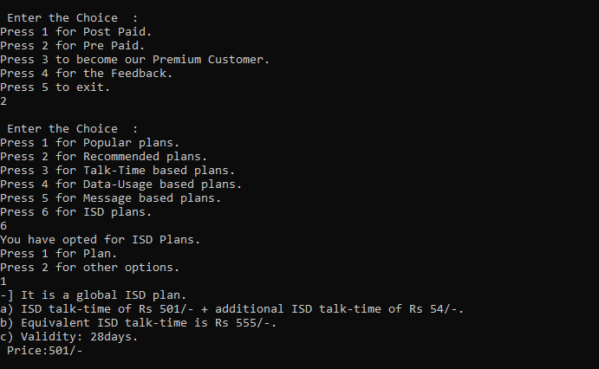

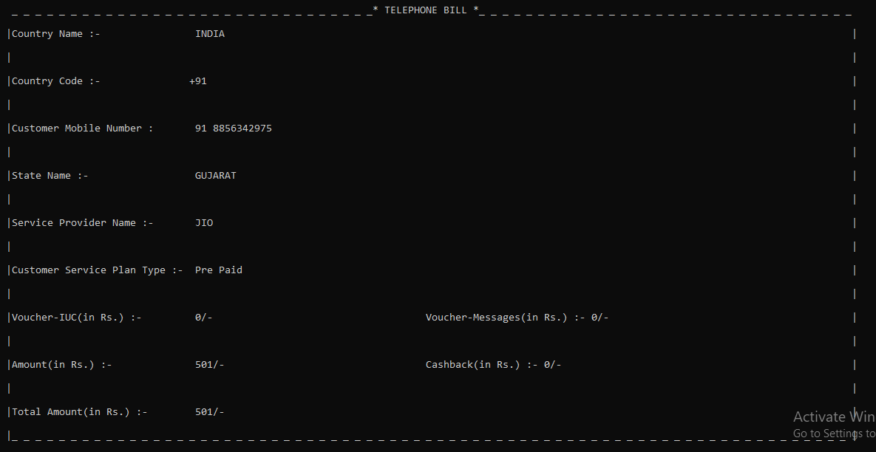

**Figure:2 D – For Pre-paid(ISD Plan) option-1**

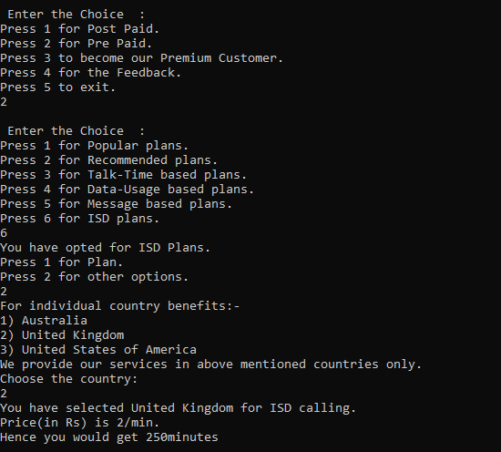

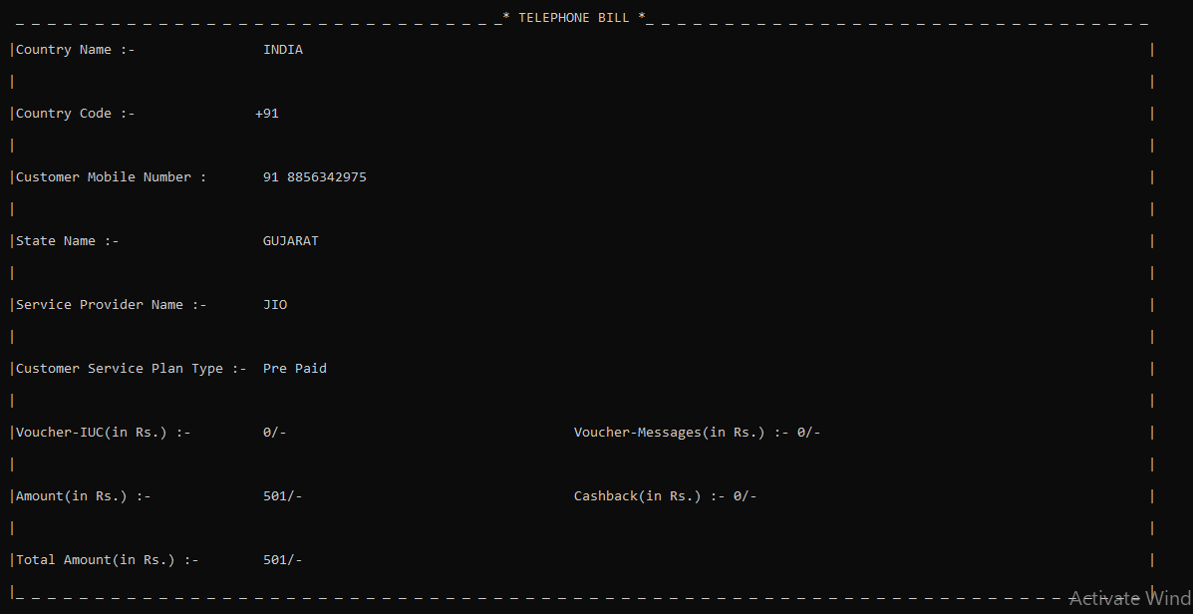

**Figure:2 D – For Pre-paid(ISD Plan) option-2**

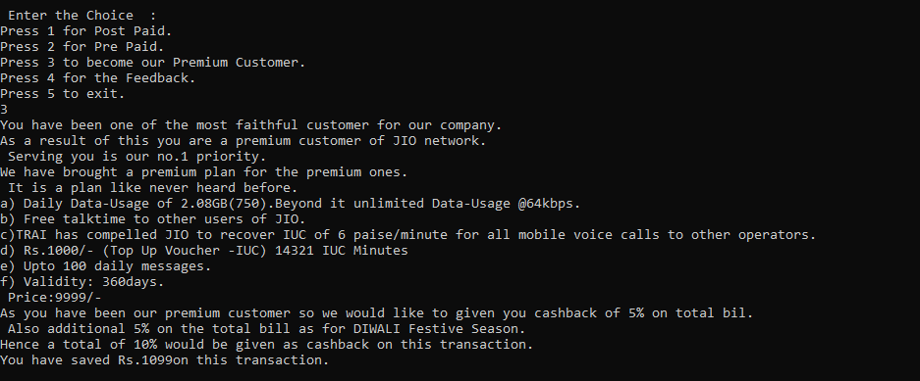

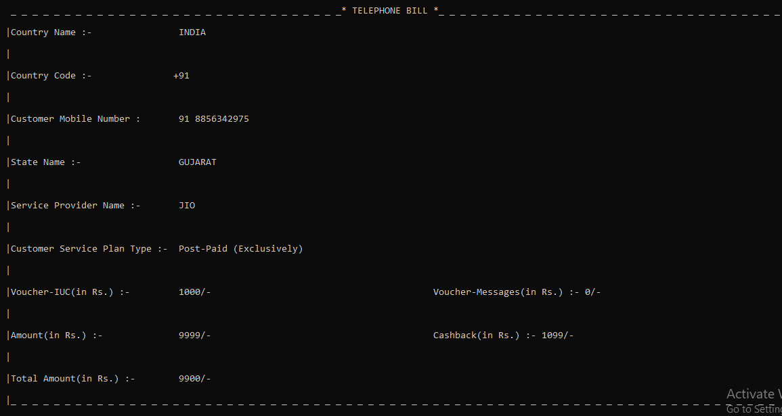

**Figure:3 – For Premium customer**

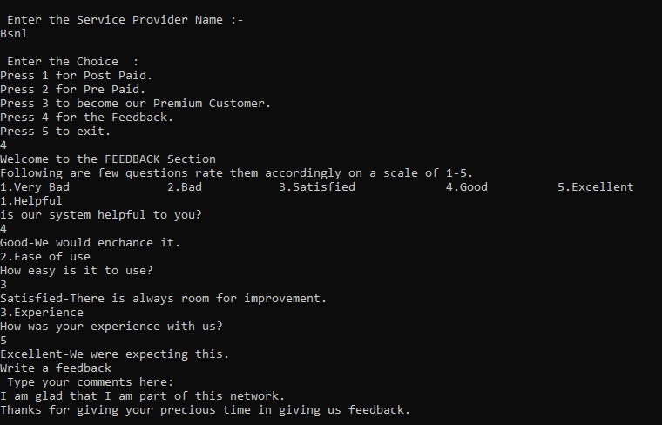

**Figure:4 – For Feedback**

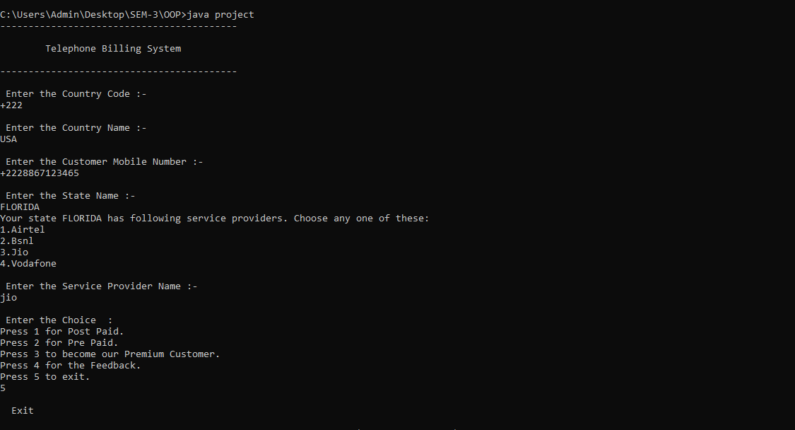

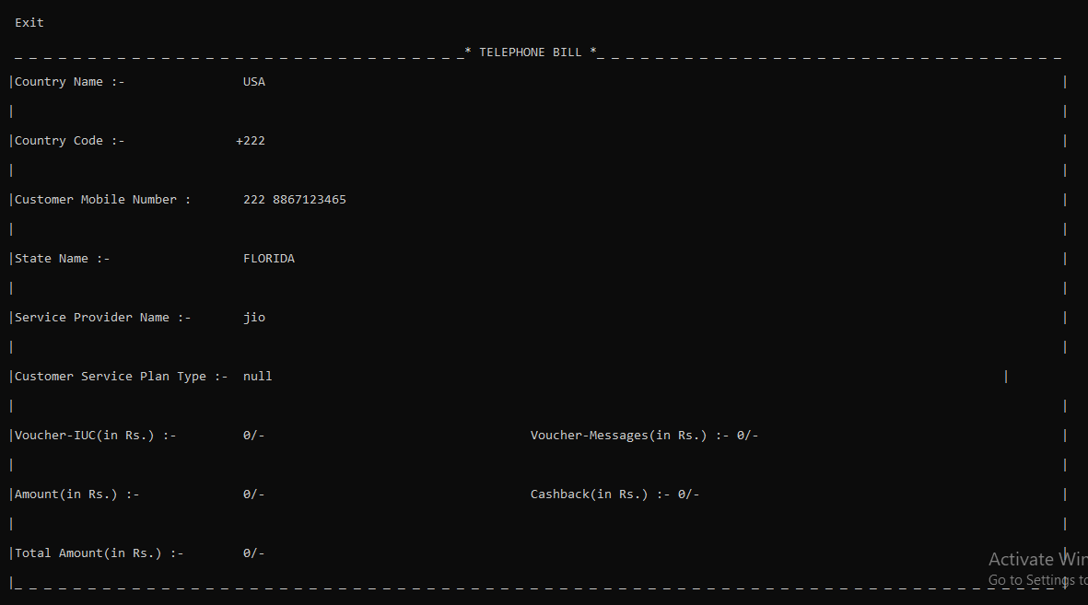

**Figure:4 – For Exit**

**TELEPHONE BILLING SYSTEM**

**References –**

1. Google Images
2. Geeks for geeks
3. Codewithc.com
4. Javatpoint.com
5. Jio.com

**Conclusion:**

To overcome the drawbacks and complexities of the existing system, this Telephone Billing System Project in Java platform was proposed. It eliminates the need of registers and files in many cases as the proposed system is fully computerized. It is quick, user-friendly and accurate, and does not create complications in telephone billing and management process.